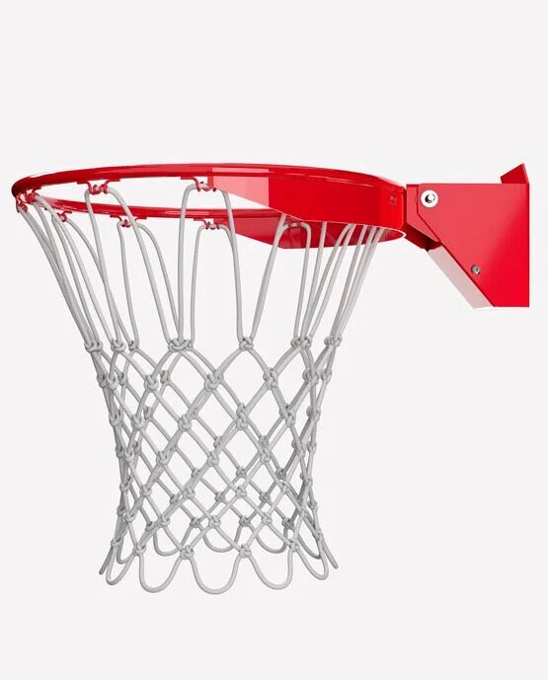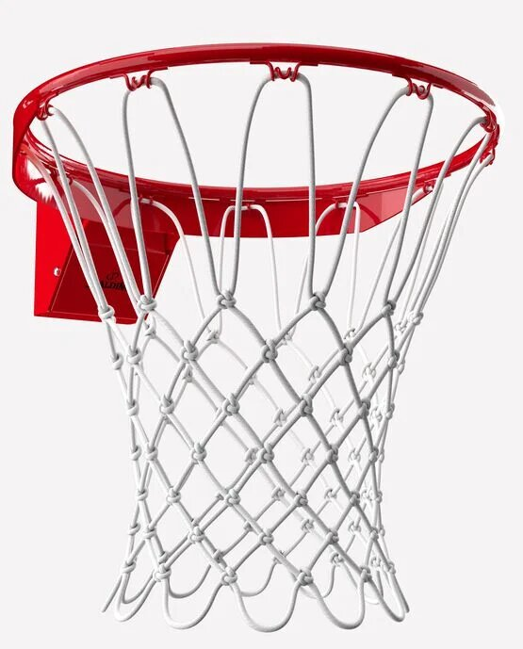

SPALDING PRO IMAGE RIM

Finish with finesse at the Spalding Pro Image Basketball Rim. Compatible with most Spalding and Huffy Sports backboards, this steel rim is designed for a smooth breakaway. It has a powder-coated finish and enclosed springs for extra defense against the elements.

**DETAILS:**

* 3” x 4” mounting bracket
* Steel breakaway rim
* Spring return mechanism
* Powder-Coated finish
* Fits most Spalding and Huffy Sports backboards
* Includes all-weather net
* Designed for outdoor play
* Backed by Spalding’s Warranty